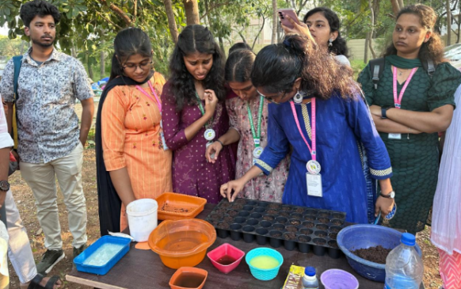
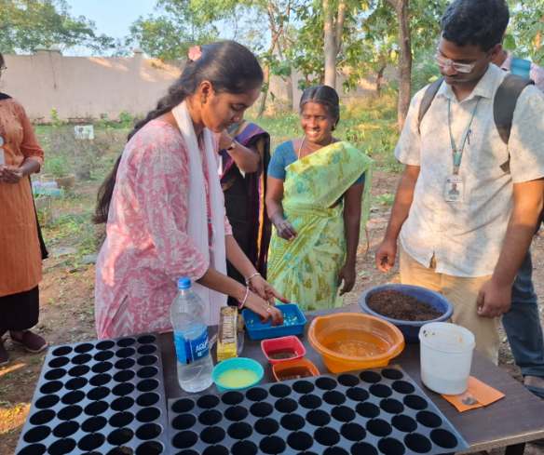
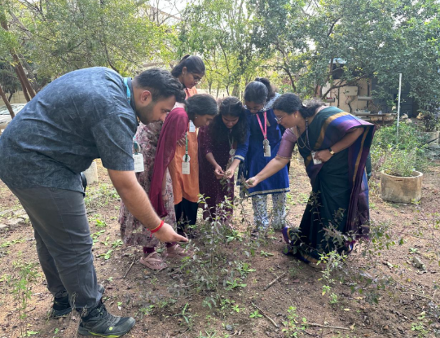
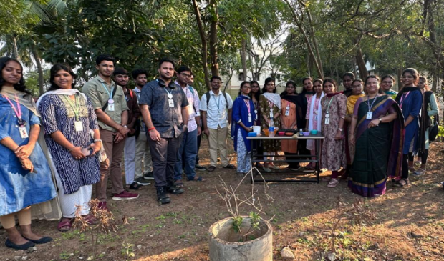
Workshop on Seed Sowing and Natural Fungicide Treatment

On 21.01.2026, Orgagen conducted a hands-on workshop on Seed Sowing and Natural Fungicide Treatment, with the guidance of Prof. Dr. A. Sathya to introduce students to eco-friendly seed treatment and plant growth analysis. Adenium (Desert Rose) and Butterfly Pea (Clitoria ternatea) seeds were treated using baking soda, neem-based, and cinnamon–clove fungicidal preparations and were sown with labelling for observation. Participants also visited the herbal garden and learned about the medicinal importance of plants with hands on observation. Students from various disciplines including Biotechnology, Computer Science, and Mechanical Engineering actively participated.The workshop effectively combined practical learning, environmental awareness, and sustainable agricultural practices.

